**BITS PILANI, DUBAI CAMPUS**

**DUBAI INTERNATIONAL ACADEMIC CITY, DUBAI**

**FIRST SEMESTER 2023 – 2024**

**COURSE:** CSF303 (Computer Network)

**COMPONENT:** Tutorial Sheet 5 **DATE:** 11th March 2024

1. A message 1001 1100 1010 0011 is transmitted using the Internet Checksum (using 4-bit words). What is the value of the checksum?

1001

1100

1010

0011

0000

Sum = 100010

Wrapped Sum = 0010 + 10 = 0100

Checksum = 1011

1. Calculate possible values of back off time *TB* for different values of no. of attempt K when stations on an ALOHA network are a maximum of 600 km apart and the signals are propagate on the channel at the speed of 3 X 10^8 m/s.

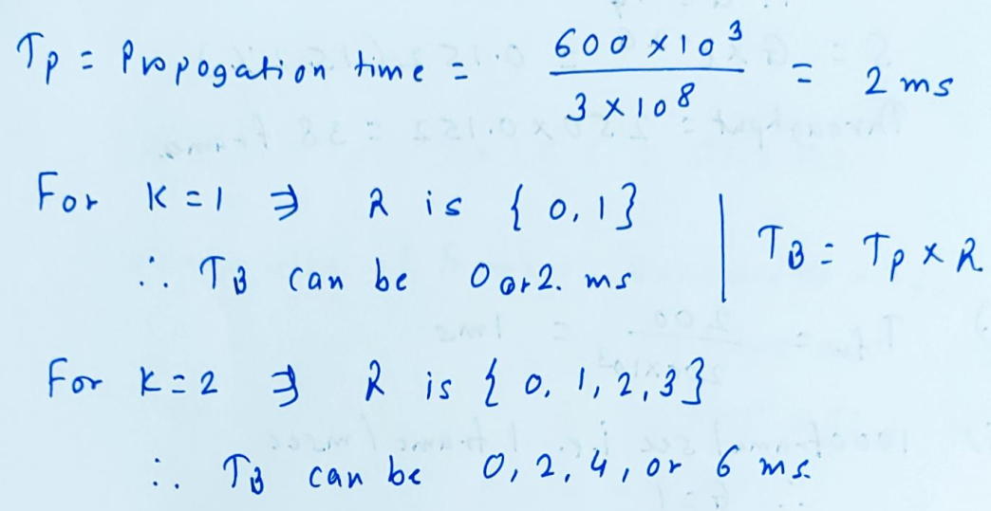

1. A pure ALOHA network transmits 200-bit frames on a shared channel of 200 kbps. What is the requirement to make this frame collision-free?

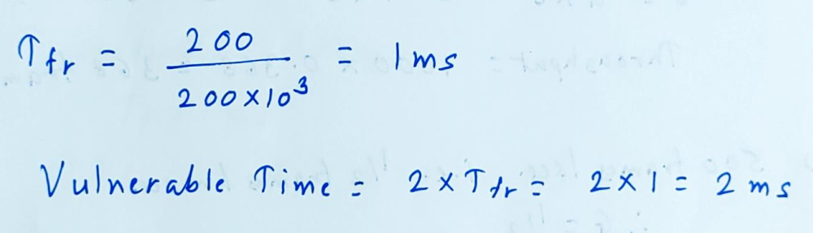

1. A pure ALOHA network transmits 200-bit frames on a shared channel of 200 kbps. What is the throughput if the system (all stations together) produces?
   1. 1000 frames per second
   2. 500 frames per second
   3. 250 frames per second

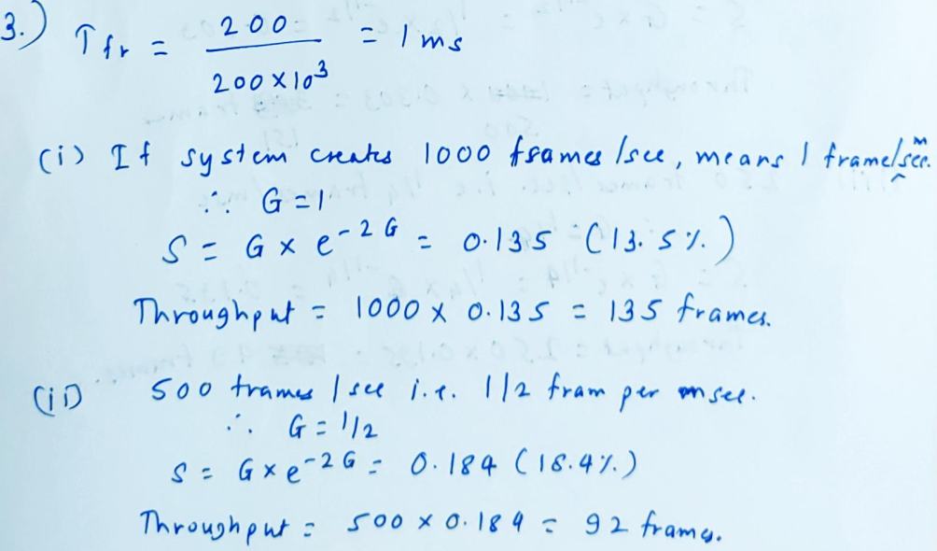

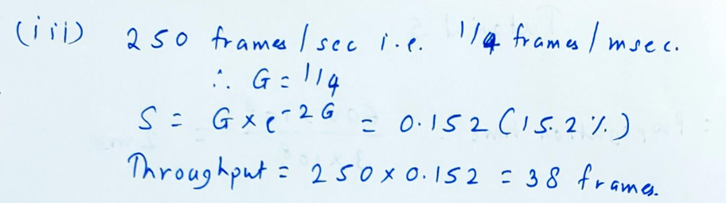

1. A Slotted ALOHA network transmits 200-bit frames on a shared channel of 200 kbps. What is the throughput if the system (all stations together) produces?
   1. 1000 frames per second
   2. 500 frames per second
   3. 250 frames per second

